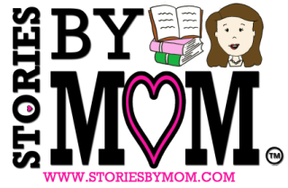 | Stories By Mom News
Naughty Ned and Wild Hair Sue Book Launch

Hi! I wanted to share with you the latest Children’s Book from Stories By Mom now available on Amazon, “Naughty Ned and Wild Hair Sue.”
It is about a little girl whose hair grows out of control when her hair knot Ned comes to play.
Join the Book Launch between 2/28 and 3/4.
WIN a paperback copy of the book of your choice (I Miss You or Ned and Sue) by sharing a post on your social media with the hashtag #nedandsuebooklaunch (share the below images or visit Facebook or Twitter)
OR Share this email and cc:info@storiesbymom.com
If you Subscribe to the Newsletter you could win a $5 Amazon gift card. If you are already signed-up send this email to a friend and cc: info@storiesbymom.com
Lastly, to celebrate our latest book, our first book “I Miss You All Day All Week” will be FREE to download to Amazon Kindle.
Please SHARE in our Excitement!
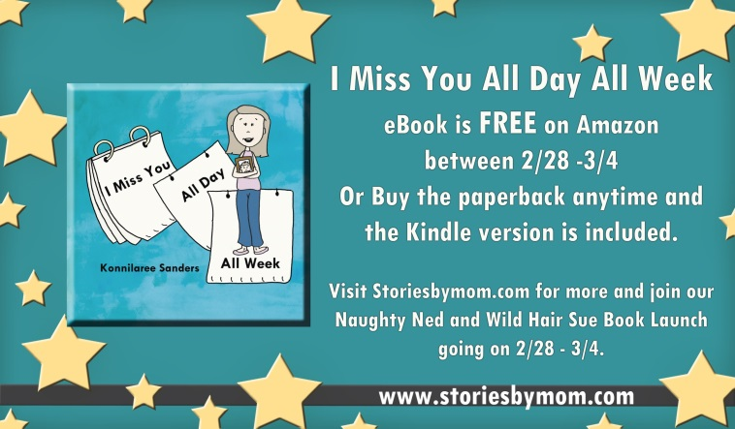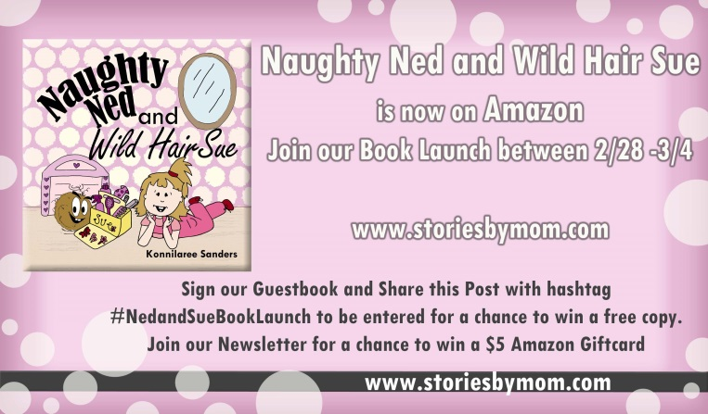
Happy Reading!
Thank you for subscribing! While you're waiting for the next update, please check out www.storiesbymom.com. You can also connect with us right now. And you can always email info@storiesbymom.com I love to get your feedback. – Konnilaree Sanders

If at any time you wish to stop receiving our emails, please email UNSUBSCRIBE to info@storiesbymom.com

Copyright © 2016 STORIES BY MOM. All Rights Reserved. MESA AZ. Info@storiesbymom.com

